SOEN 357 – Section S
Mini Project Report
Winter 2026 – Concordia University
Ammar Ranko - 40281232
2026-02-20


Table of contents
1. Introduction 2
1.1 Context 2
1.2 Problem Statement 2
1.3 Design goals 3
1.4 Target Users & Scope 3
2. Research 3
2.1 Research Goals 4
2.2 Methodology 4
2.3 Key Findings 6
2.4 Design Decisions & Implications 9
3. Personas 11
3.1 Context 11
3.2 Sarah Valkov – Busy Self Manager 12
3.3 David Rando – Clarity and Accessibility Seeker 13
3.4 Leila – Care Coordinator 15
4. User Journeys 16
4.1 Context 16
4.2 Sarah’s Journey 16
4.3 Davids’s Journey 17
4.4 Leila’s Journey 18
5. Storyboard 18
6. User Flow 20
7. Initial Sketches, Wireframes and Prototype 20
7.1 Initial Sketches 20
7.2 Wireframes 22
7.3 Prototypes 25
8. Usability testing 25
8.1 Purpose and Evaluation Goals 25
8.2 Method and tools 25
8.3 Participants, Recruitment and setup 26
8.4 Tasks 26
8.5 Metrics 27
8.6 Analysis and Iteration Plan 27
9. Reflection 28
10. References 29

1. Introduction

1.1 Context
How many times have you forgotten to take your medication? Or, perhaps more importantly, how many people do you know who struggle with daily adherence? For many, the answer is “too often.”
Patients with chronic conditions frequently struggle to manage complex medication schedules and keep track of upcoming doctor’s appointments. Unfortunately, existing digital solutions are often either too complex or too fragmented to be truly helpful.
The goal of this project was to design MedicNova, a health companion “super app” that consolidates these essential features into a seamless, stress-free experience. The app enables patients to set reliable reminders, track medication usage, schedule appointments, and communicate directly with healthcare professionals.

1.2 Problem Statement
If we look at the problem closely from a user perspective, we notice that the main challenges are related to remembering to take medication and managing treatment routines consistently. More precisely, we can break the problem down as follows:

- Remember medications consistently — Users often forget doses due to busy schedules, interruptions, or an inconsistent daily routine.

- Track adherence over time — Users need a simple way to log doses and review patterns so they can see whether they are staying on track.

- Reduce “Did I take it?” uncertainty — Users frequently second-guess themselves and need clear confirmation to avoid missed or double doses.

- Coordinate appointments — Users struggle to keep up with follow-ups, renewals, and medical visits, especially when juggling multiple providers.

- Communicate easily with healthcare professionals — Users want to share accurate medication and adherence information to get better guidance and care decisions.

1.3 Design goals
Since illness does not discriminate by age, MedicNova is designed to be adaptable for a wide range of users through strong UI accessibility features and personalization options. The core focus of the app is simplicity: keeping the experience clear, direct, and free of unnecessary clutter.

MedicNova aims to:
- increase adherence through reliable, actionable reminders
- reduce uncertainty through visible confirmation states (Taken + timestamp)
- support busy contexts via minimal-step logging
- avoid notification fatigue via flexible reminder styles
- support accessibility with readable UI and large tap targets

1.4 Target Users & Scope
Primary users: Adults who manage their own medications (typically 2–5 doses/medications per day).

Secondary users: Caregivers who manage medications on behalf of a family member or dependent.

Prototype scope: Core medication management workflow (reminders + tracking), appointment scheduling, and messaging with healthcare professionals.

2. Research
To build a medication app that truly works, I needed to understand the real-life habits behind it. I started with a user survey to see how people handle their meds daily. I learned how often they forget a dose, the workarounds they use, and what app features matter most to them. Next, I backed up those findings with a literature review of healthcare and HCI research to ensure my insights aligned with proven scientific principles. Combining direct user feedback with established research gave me a strong, evidence-based foundation for all the design choices in the MedicNova prototype.

2.1 Research Goals
- Identify why people miss or delay medication doses
- Understand current strategies (alarms, organizers) and where they fail
- Determine feature priorities
- Translate findings into design requirements grounded in HCI + health literature

2.2 Methodology
2.2.1 Primary Research
A survey is effective in early UX research because it quickly reveals patterns across multiple users in a short time. It produces measurable data that helps prioritize features based on evidence rather than assumptions. For this project, a survey was especially appropriate because medication adherence involves routine behaviors that vary across individuals, which makes it a reliable information gathering strategy, as it aligns with our user choice.
The survey focused on gathering insights into:
- number of medications taken daily
- age
- frequency of missed/delayed doses
- tools used to remember medication
- main reason for missing doses
- feature importance (1–5)
- reminder preference (discreet vs persistent vs adaptive)
- frustrations with existing health apps

Focusing on these key areas allowed us to gather actionable, real-world data on how people handle their prescriptions. The key takeaways from the participants are summarized below.

Results (Compact Summary):
Sample: 12 participants
Role: 83% self-manage medication (10); 17% are caregivers (2)
Age: Largest groups were 25–34 (33%) and 55+ (25%)
Medication load: 83% manage 2–5 medications daily (2–3: 42%; 4–5: 42%)
Miss frequency: 75% miss or delay doses weekly or more (1–2/week: 42%; 3+/week: 33%)
Current strategies: Phone alarms (58%) and pill organizers (25%)
Top reasons for missing: Too busy (33%), forgot (33%), unsure if already taken (25%)
Top usability frustrations: Small text (33%), too many steps (25%)
Feature priorities: Reliable reminders ranked highest (92% rated 5/5), followed by quick logging; doctor messaging ranked lower
Full Results Data: Click here

2.2.1 Secondary Research
To complement the survey results and strengthen the design rationale, I conducted secondary research on medication adherence and HCI principles relevant to reminder-based health systems. This literature review provides broader context on adherence rates, common causes of missed doses, and evidence-based design strategies such as interactive confirmations, visible system state, and notification approaches that reduce fatigue:

Medication non-adherence is a significant global issue. The World Health Organization reports that adherence to long-term therapies averages approximately 50% in developed countries [1]. Forgetfulness and routine disruption are among the most reported causes of missed doses [2]. Digital reminder systems have been shown to significantly improve medication adherence. A meta-analysis published in the Journal of Medical Internet Research found that mobile-based reminder interventions increase compliance, especially when users can actively confirm actions rather than relying on passive alerts [3]. From a human–computer interaction perspective, reducing cognitive load is essential in healthcare systems. Norman explains that effective design should minimize reliance on memory by making system states visible and providing clear feedback [4]. In medication management contexts, visible confirmation of completed actions reduces uncertainty and error. Additionally, research on mobile notifications shows that excessive alerts contribute to disengagement and reduced responsiveness over time [5]. Adaptive notification strategies improve long-term engagement while avoiding fatigue. Overall, existing literature emphasizes the importance of reliable interactive reminders, visible confirmation states, and adaptive notifications in medication management applications.

2.3 Key Findings

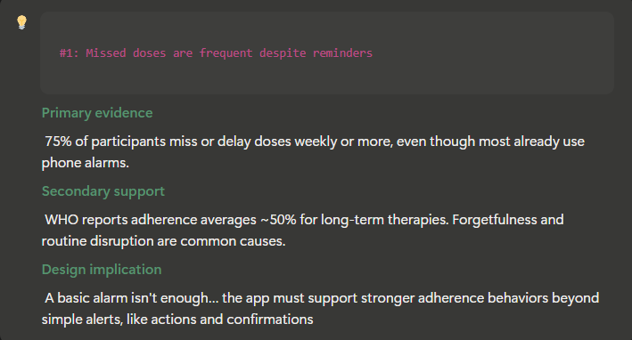
Figure 1: Key finding #1

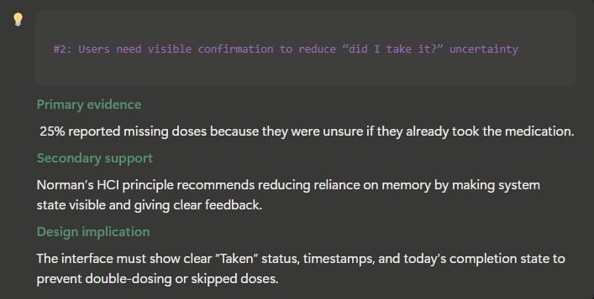
Figure 2: Key finding #2

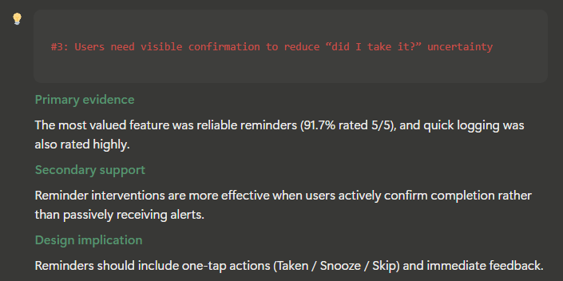
Figure 3 Key finding #3
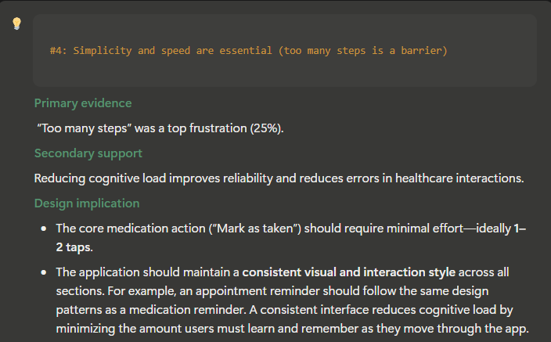
Figure 4: Key finding #4
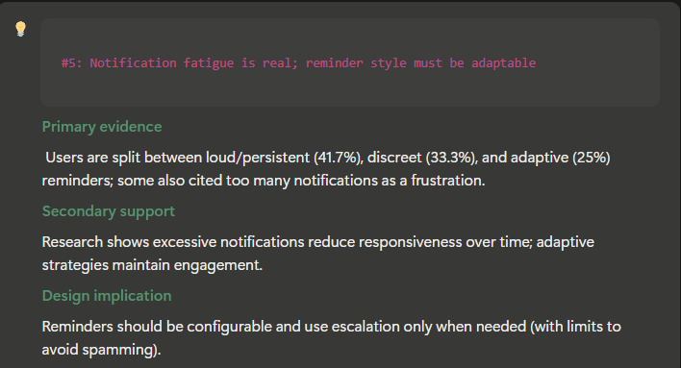
Figure 5: Key finding #5

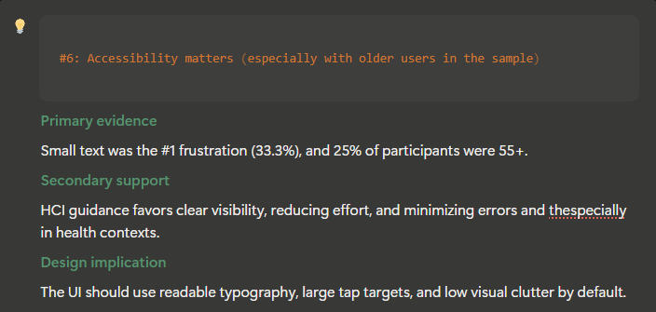
Figure 6: Key finding #6

2.4 Design Decisions & Implications

1 — Build interactive reminders that require confirmation (Taken / Snooze / Skip)
Based on Findings: 1, 3
Because missed doses are frequent even with alarms and reliable reminders are the top priority, reminders must support quick actions directly from the notification:
- One-tap Taken, Snooze, Skip
- Immediate feedback (state updates instantly)

2 — Make medication status highly visible to eliminate uncertainty
Based on Findings: 2
To address “unsure if already taken,” the app must make system state obvious at all times:
- Show Last taken time (timestamp) on the home screen
- Show a List of medicaments to take for the day
- Show Next scheduled dose prominently

3— Minimize steps: logging must be fast enough for busy contexts, but in the same time require a confirmation
Based on Findings: 3, 5
Since our dislike “too many steps” and value quick logging, the core workflow should be designed for speed:
- Marking a dose as taken should be ≤ 2 taps in-app
- Intentional confirmation: Instead of a single tap, requiring a two-tap sequence solves a major problem: users frequently forgetting if they actually took their medication. A single tap is too easy to do on autopilot. By requiring a deliberate second tap to confirm, the app creates a moment of mindfulness. Combined with a clear visual update on the screen, this physical action helps cement the event in the user's memory, giving them complete confidence that the dose was logged. Additionally, this two-step process prevents accidental misclicks, ensuring a user does not mark a medication as taken when they actually intended to hit snooze, for example.

4— Use an escalation-based reminder strategy without causing notification fatigue
Based on Findings: 4
Because reminder preferences vary and fatigue reduces engagement, reminders should be configurable and adaptive:
- Allow users to choose Discreet / Persistent / Adaptive
- If no response, escalate gradually (e.g., discreet → persistent)
- Allow users to add a maximum number of reminders to to avoid spamming

5— Support multi-medication complexity with a scalable “Today” structure
Based on Findings: 5, 6
Since most participants manage multiple medications and commonly miss doses, the interface should scale without confusion:
- “Today” view grouped by time blocks (Morning / Afternoon / Evening)
- Current status easily visible
- Easy access to medication details without breaking the main flow

6— Make a clear and easy menu with visible icons
Based on Findings: 4
Since simplicity and avoiding too many steps are key aspects that our users are looking for, we need to design the navigation in a way that makes it highly visual and straightforward.
- A bottom navigation menu with clear icons for the main page, logs, appointments, and messages.
- Place the settings icon in the top right corner to maximize menu space for more important daily features. Because settings do not directly relate to the core daily purpose of the app, moving them out of the bottom bar saves valuable screen space fore core features and aligns with standard design patterns users already expect.

3. Personas

3.1 Context
To ensure the design is grounded in real user needs, I translated the survey results and the supporting literature findings into three representative personas. Rather than describing individual participants, these personas summarize the most common behavioral patterns observed in the data, such as missed doses due to being busy, uncertainty about whether a dose was already taken, accessibility concerns, and the need for efficient appointment scheduling and doctor messaging.
Each persona reflects a distinct usage focus within MedicNova: Sarah represents the busy self-manager who needs fast, low-friction reminder interactions; David represents low-tech users who prioritize clarity and simplicity, confirmation, and accessibility to avoid errors; and Leila represents users who rely on the app for care coordination tasks like booking appointments and communicating with healthcare professionals. Together, they provide complementary perspectives that cover the core workflows of the application and directly inform the prototype decisions.

3.2 Sarah Valkov – Busy Self Manager
Sarah represents the most common pattern in the survey: self-managed medication in a busy lifestyle, where doses are missed or delayed mainly due to being busy or forgetting, even when phone alarms are used. Her persona emphasizes the need for fast, low-friction interactions (one-tap Taken/Snooze/Skip and minimal steps), reflecting the survey findings that users value reliable reminders and quick logging and are frustrated by too many steps.
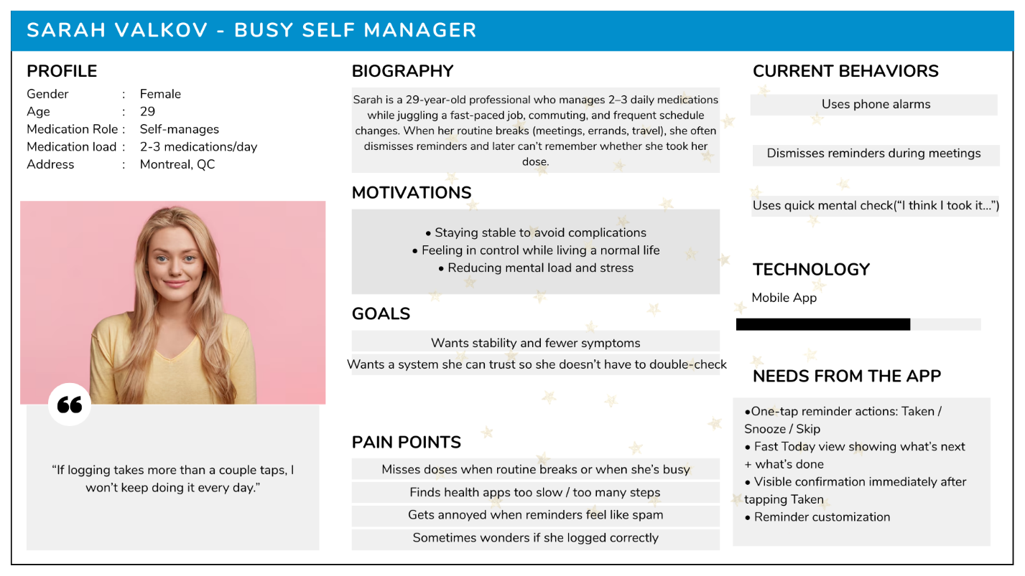
Figure 7: Sarah's Persona

3.3 David Rando – Clarity and Accessibility Seeker
David represents users who are low on tech and users who struggle most with verification and confidence, especially when taking multiple medications. This persona is grounded in the survey insight that a significant portion of users miss doses due to being unsure whether they already took the medication, as well as complaints about small text and usability barriers. David highlights why MedicNova must prioritize visible confirmation states, timestamps, and accessible UI defaults (readability and large tap targets).
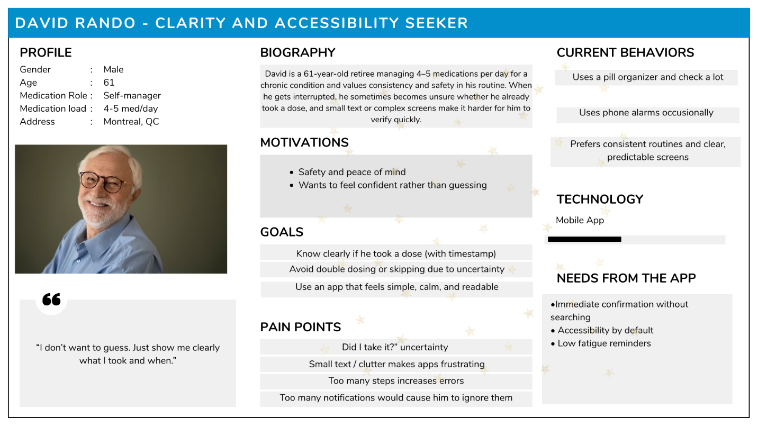
Figure 8: Davis’s Persona

3.4 Leila – Care Coordinator
Leila represents users who rely on healthcare tools not only for medication adherence but also for care coordination, especially appointment scheduling and doctor/clinic messaging, which are core parts of the project scope. This persona reflects the same survey-driven need for simplicity and clear feedback, applied to coordination tasks: booking an appointment quickly, adding a question/note, and sending a message with confidence that it was delivered. Leila ensures the design supports the broader workflow of managing health beyond daily reminders.

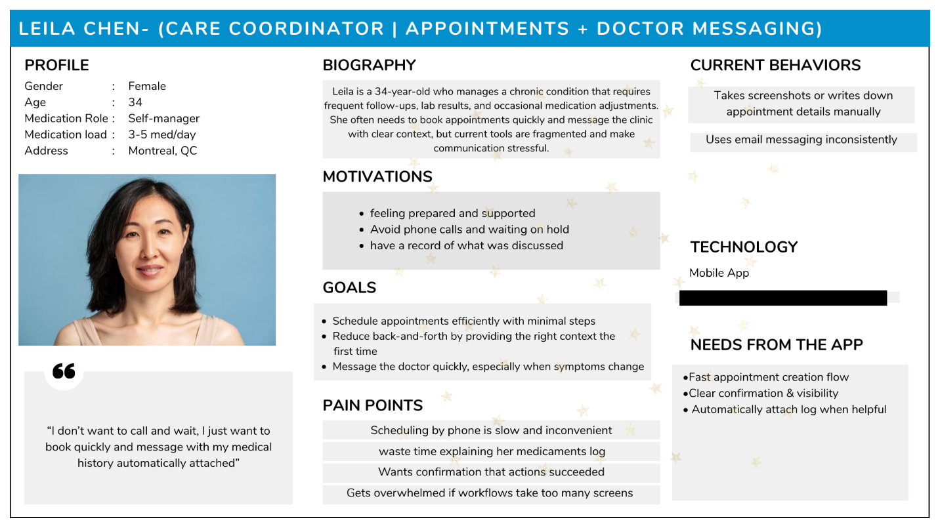
Figure 9: Leila’s Persona

4. User Journeys

4.1 Context
To complement the personas and demonstrate how MedicNova fits into real-life use, I created a user journey map for each persona. Each journey map illustrates the user’s end-to-end experience while completing a realistic scenario, including key touchpoints) the user’s actions and thoughts, emotional highs and lows, and the pain points where breakdowns typically occur. This will help me because it clearly connects my research findings to real user workflows, showing where pain points occur and how my prototype decisions address them, which may show flows in my design and allow me to fix them

4.2 Sarah’s Journey

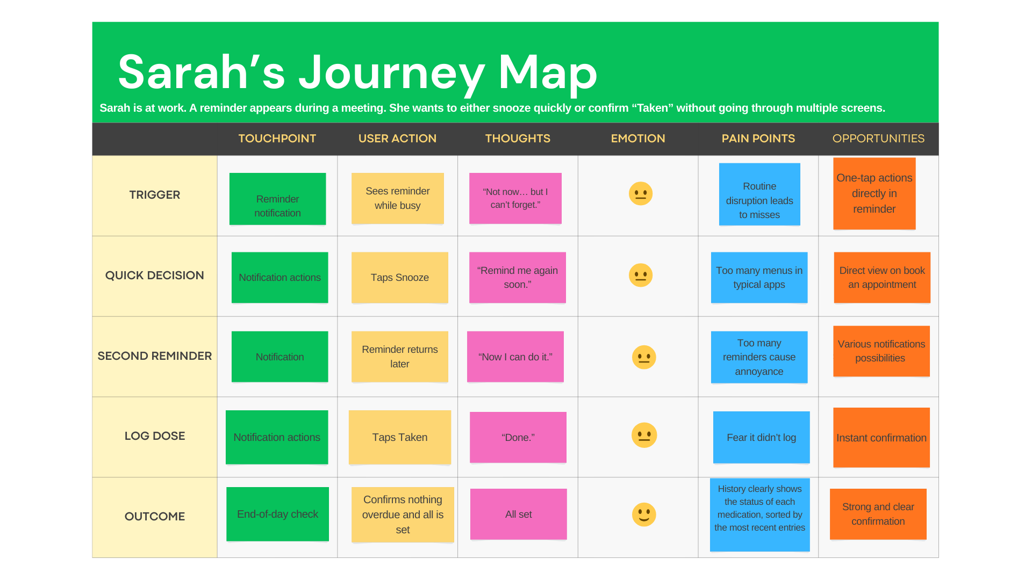
Figure 10: Sarah’s Journey

4.3 Davids’s Journey
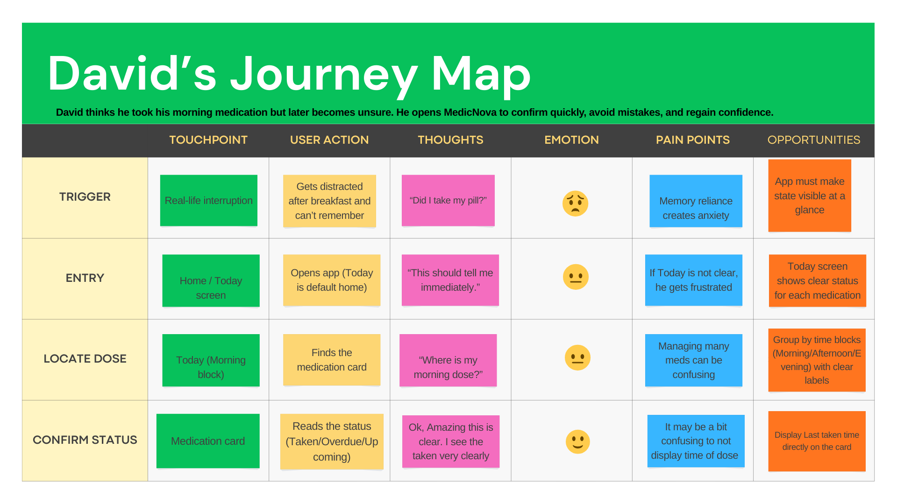
Figure 11: David’s Journey
  - 4.4 Leila’s Journey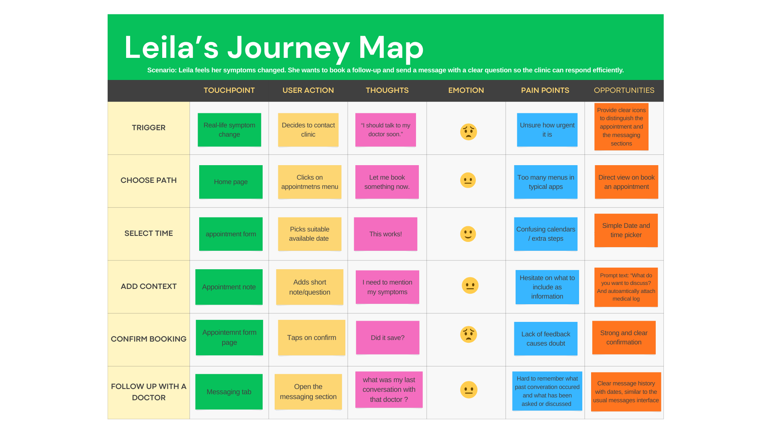
Figure 12: Sarah’s Journey

Storyboard

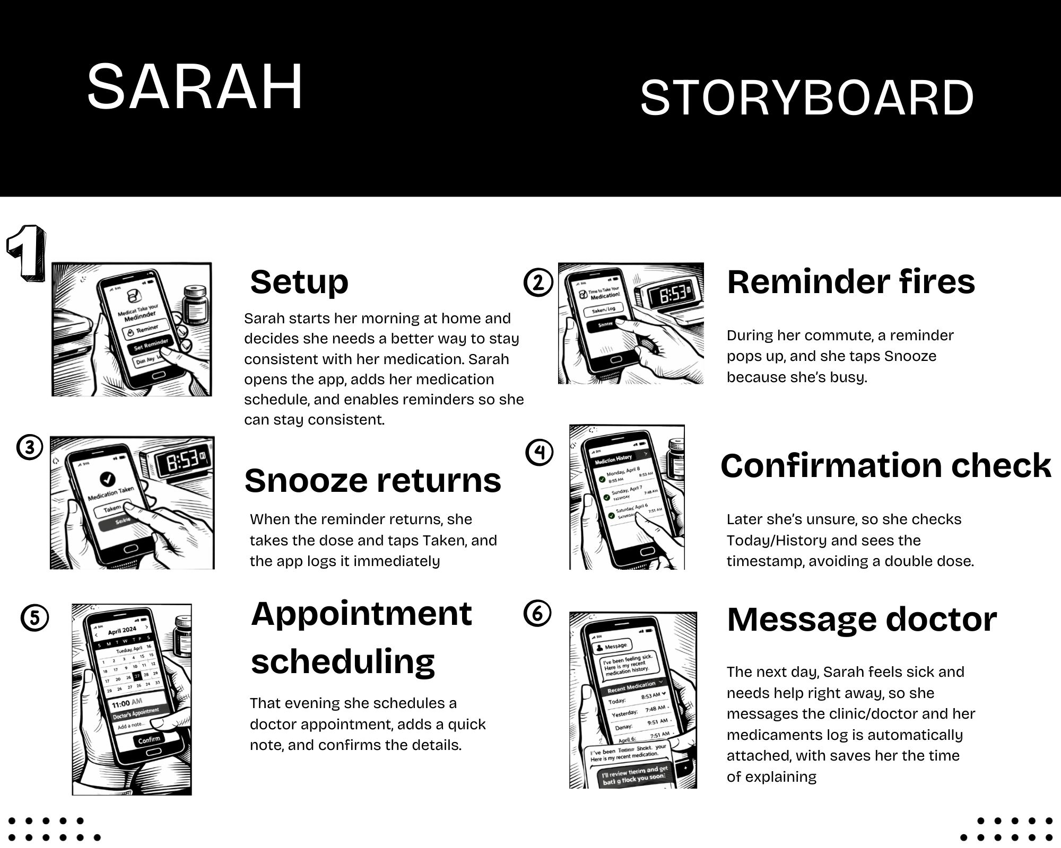
Figure 13: Sarah's extended storyboard

This storyboard illustrates a realistic end-to-end day-in-the-life scenario for Sarah, showing how MedicNova supports the core workflows of the app in context. Across six steps, it demonstrates the reminder loop (Snooze → Taken → logged confirmation with timestamp) and extends into care coordination features (appointment scheduling and doctor messaging with an attached medication log), highlighting how the design reduces missed doses, prevents “did I take it?” uncertainty, and keeps actions quick and clear.

User Flow

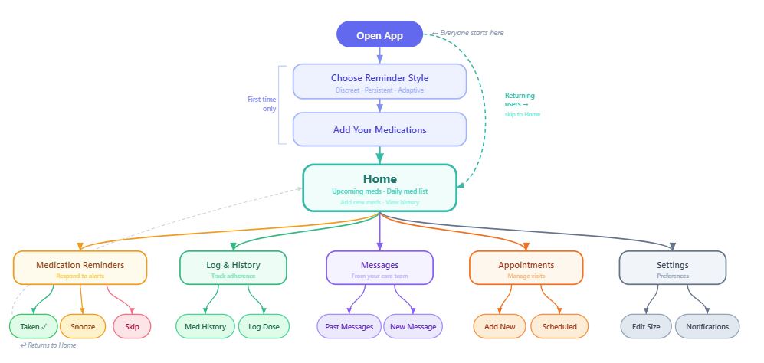
Figure 14: high-lever user flow

This user flow provides a high-level overview of how users navigate MedicNova from launch to completing the app’s core tasks. It shows the first-time setup path (choosing a reminder style and adding medications) leading into the home screen as the main hub and then maps the primary branches for daily use: responding to medication reminders (Taken/Snooze/Skip), logging and reviewing adherence history, messaging the care team, scheduling appointments, and adjusting preferences in Settings.

Initial Sketches, Wireframes and Prototype

7.1 Initial Sketches
During the design process, and before conducting the survey, I explored several ideas, some of which I kept, and others I discarded once the survey results showed they were not aligned with user needs. For example, in my early sketches I planned a constant, loud reminder with no limit until the user took the medication. My initial assumption was that repeated reminders would benefit users by ensuring they take their dose on time.

However, this approach did not hold after conducting research. The survey and supporting literature indicated that some users are highly sensitive to frequent notifications and may become discouraged or overwhelmed due to notification fatigue. As a result, I replaced the “no-limit” reminder concept with a more adaptive notification system that allows users to choose between three reminder styles (Discreet, Persistent, or Adaptive) to better match different preferences. The following sketches cover most main areas of the application.

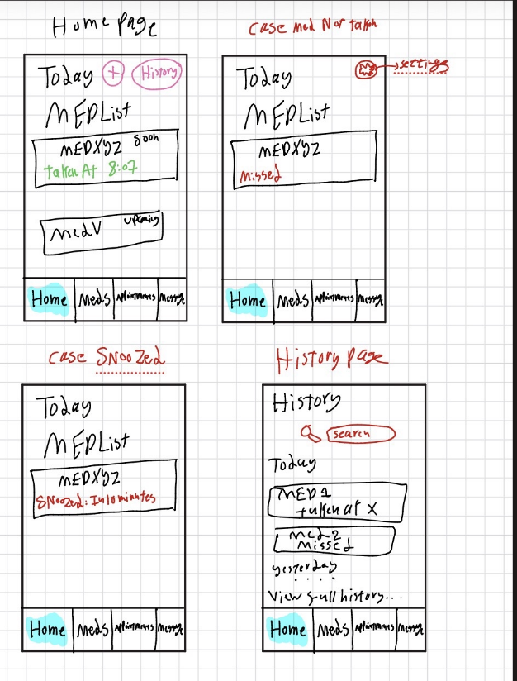
Figure 15: Initial sketches - part1

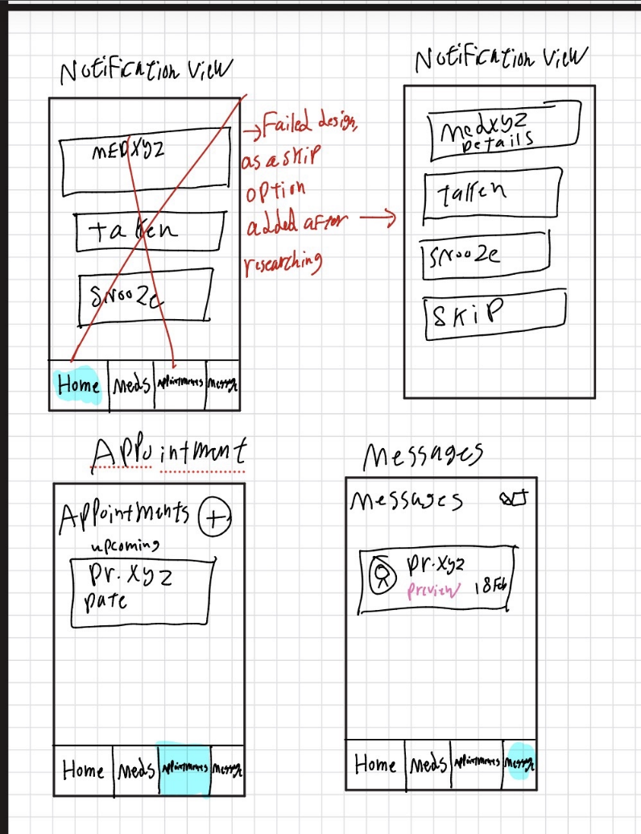
Figure 16: Initial sketches-part 2

7.2 Wireframes
These wireframes translate the research findings and design requirements into a structured layout of the MedicNova interface. They define the key screens and interactions, especially the daily medication workflow (reminders, quick logging, and visible confirmation with timestamps),as well as appointment scheduling and doctor messaging. By focusing on structure before final visual styling, the wireframes ensure the navigation and information hierarchy are clear and usable.

The wireframes cover the app’s main pages and the most common user needs. They also include a mix of default large-text views (based on the accessibility design decisions) and standard views. As a result, some screens may appear larger than others; this is intentional and is meant to illustrate how the interface adapts to different readability settings.
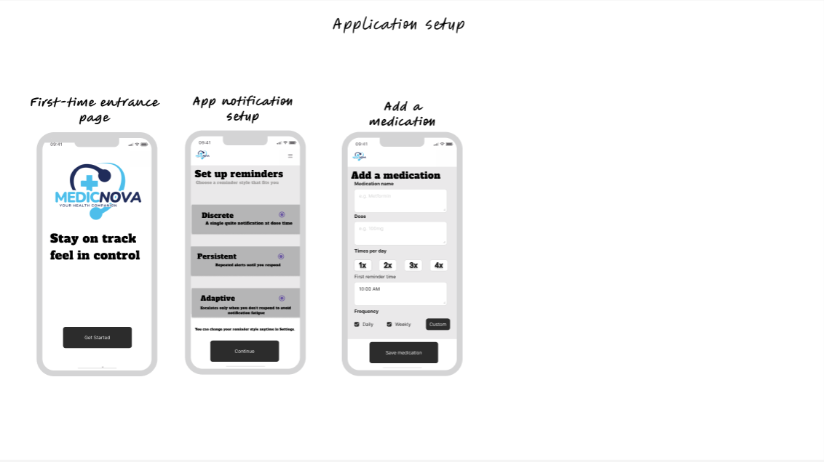
Figure 17: Application setup wireframes
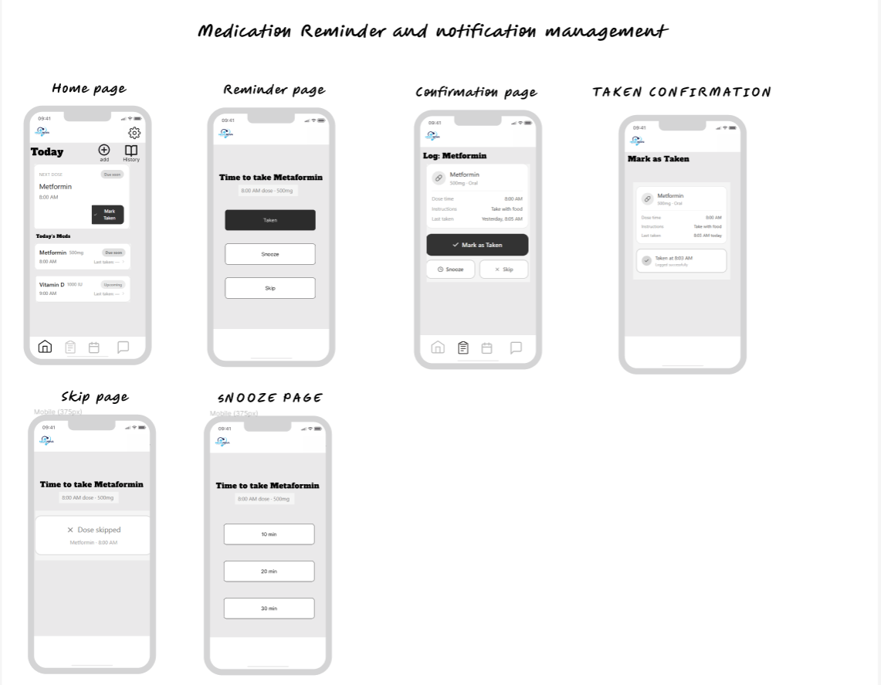
Figure 18: Medication Reminder and notification management
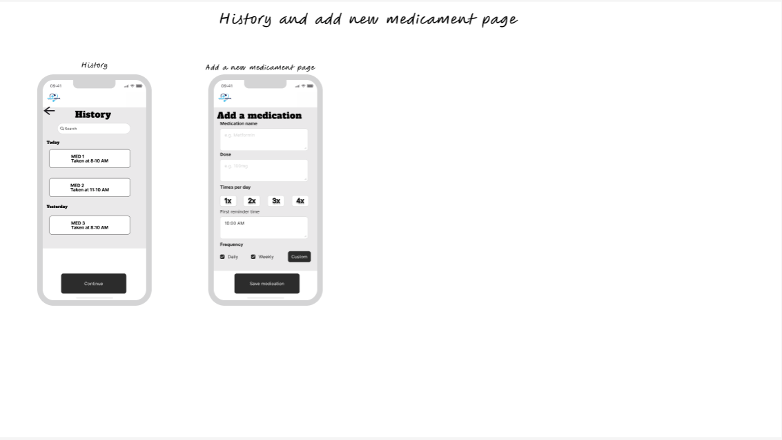
Figure 19: Medicament History and add a new medicament page

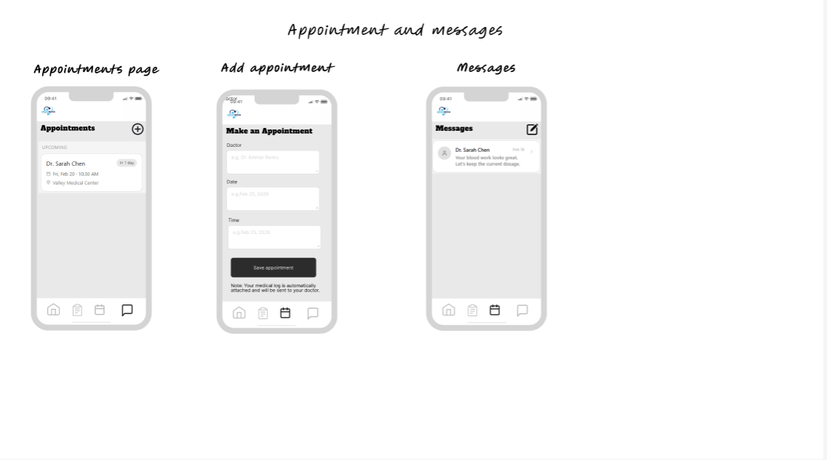
Figure 20: Appointments and wireframes pages

7.3 Prototypes
Now, after exploring ideas through sketches and refining them into wireframes, the prototype was designed by applying colors and detailed UI elements to bring the concept to life as a clickable, interactive, and demo-ready experience.

Usability testing

8.1 Purpose and Evaluation Goals
The purpose of usability testing I will be conducting is to evaluate whether users can complete MedicNova’s core workflows efficiently and confidently using the clickable prototype. This test focuses on identifying usability issues related to navigation clarity, interaction speed, and feedback/confirmation states, especially for critical medication actions where errors can lead to missed doses or uncertainty.
Because MedicNova is a prototype, the test aims to uncover:
- where users hesitate or deviate from the expected flow,
- which UI elements are misunderstood or overlooked,
- whether confirmation and recovery flows reduce “did I take it?” uncertainty.
This test will be a quantitative and qualitative based test where both data and results will be extracted and the following criteria will be looked up closely:
- Effectiveness: can users’ complete tasks correctly (success rate, errors)?
- Efficiency: how quickly and with how many steps do they complete tasks (time, clicks)?
- Satisfaction: how easy/confident do users feel (qualitative feedback)?

8.2 Method and tools
Method: Remote, unmoderated usability testing [6]
Tool: Maze (linked to the interactive prototype)
Maze is appropriate because it collects both behavioral and self-reported data in a scalable way, including:
- task success/failure,
- time on task,
- misclicks / click heatmaps,
- path analysis (expected vs actual navigation),
- embedded post-task questions for qualitative feedback.
This approach is efficient for testing a prototype quickly while still producing measurable usability signals. Maze also generates a report after the test is completed, including heat maps and detailed insights, which makes the task of analysing much easier and simpler

8.3 Participants, Recruitment and setup
Target participants: Adults who use a smartphone daily and either:
- manage their own medication (primary), or
- have experience managing medication occasionally (secondary)

the test will be conducted on a sample of at least 20 people. This will ensure a consistent number with the initial sample the application was built on. Same questions used in the survey will be used to recruit participants.
Once recruited, all participants will receive an email with a short introduction explaining the purpose of the test, general idea and presentation of the prototype participants will be testing, and the Maze test link.
Maze will capture the following data:
- navigation paths, time, clicks/misclicks, completion rates (quantitative data) ,
- short post-task ratings and comments (qualitative data)

8.4 Tasks
As we don’t overwhelm the participants with heavy testing, especially since it is the first prototype, the tasks will focus on the main functionalities of the application, avoiding too many details. As a result, the test will focus on the required scopes and happy path as follows:
Reminder → Log Taken (core loop)
“You receive a reminder. Confirm you took the medication.”
Verify Confirmation (reduce uncertainty)
“Verify the dose was logged and check the time it was taken.”
Schedule Appointment (care coordination)
“Schedule a doctor appointment for next week and add a short note.”
Message Doctor/Clinic (communication)
“Send a message to the doctor/clinic and attach a medication log if possible.”

8.5 Metrics
The test will be evaluated using a small set of usability metrics that capture both performance and user perception. Effectiveness will be measured through task success rate, whether participants can complete each mission correctly. Efficiency will be assessed using time on task and the number of clicks/taps required, since MedicNova’s core workflows are meant to be fast and low-friction. To detect confusion points, Maze’s interaction analytics will be used to review misclick hotspots (heatmaps) and path deviation, showing where users hesitate or navigate away from the expected flow. Finally, qualitative feedback will be collected after each task through short questions asking what felt confusing, what the participant expected to happen, and a simple difficulty rating (1–5) to contextualize the quantitative data.

8.6 Analysis and Iteration Plan
After the Maze study, results will be summarized for each task by reporting the task success rate, average completion time, and any recurring interaction problems such as misclicks hotspots and navigation/path deviations, supported by participants’ written comments. Observed issues will then be grouped into themes (for example, unclear confirmation, too many steps, or low discoverability of the “Attach medication log” option) and prioritized by severity: High issues block task completion or create serious uncertainty, Medium issues allow completion but cause notable friction, and Low issues are minor improvements such as wording or visual adjustments.
The findings will be used to guide iterative improvements to the prototype. Depending on the problems observed, changes may include improving the visibility of Taken status and timestamps, reducing steps in the reminder-to-logged workflow, making key actions (such as Attach medication log) easier to notice, and strengthening confirmation feedback for appointment booking and messaging. This approach ensures usability testing directly informs design refinement rather than only reporting performance metrics.

Reflection

Following the UX design process helped me move from a broad idea (“a health companion app”) to a solution grounded in specific user needs. By combining primary research (survey) with secondary research, I confirmed that medication non-adherence is often linked to forgetfulness, routine disruption, and cognitive overload rather than a lack of motivation. This shifted my focus from adding many features to designing a clear, repeatable daily workflow centered on reliable reminders, quick confirmation, and a visible dose history that reduces uncertainty. At the same time, the design still supports the required scope of the project: medication tracking, appointment scheduling, and doctor messaging, without making the interface feel fragmented or overly complex.

Before conducting research, I initially assumed that stronger reminders automatically lead to better adherence. In early sketches, I planned a constant, loud reminder with no limit and no skip option until the user took the medication, believing it would “force” success and benefit the user. However, the survey feedback made it clear that this approach could backfire: frequent interruptions can overwhelm some users and impact negatively impact their experience. As a result, I replaced the no-limit reminder concept with a more user-centered strategy that supports different preferences through selectable reminder styles (Discreet, Persistent, Adaptive) and includes a Snooze option. This change reflects an important lesson from HCI: good design does not simply push users harder, it supports them in realistic contexts and reduces cognitive burden.

Creating personas, user journey maps, and a storyboard also made the problem more concrete by revealing where breakdowns happen in everyday life. For example, busy users may dismiss reminders during meetings, while others become anxious when they cannot quickly verify whether a dose was logged. These insights directly influenced the wireframes and prototype by making reminder interactions immediately actionable (Taken/Snooze/Skip), ensuring that “Taken” status and timestamps are easy to find, and keeping key actions accessible from the Home screen. The storyboard and user flow helped ensure that the design supports complete workflows, not just individual screens across medication management, appointments, and messaging.

The main challenge I encountered was scope control. Because the assignment includes multiple features, it was easy to overdesign beyond the core user problem. I addressed this by prioritizing the workflows most strongly supported by research (reminders, confirmation, and verification) and integrating appointment scheduling and messaging as focused supporting flows rather than competing features. Another challenge was translating research into clear design choices in a compact report format. I resolved this by explicitly linking findings to design implications and mapping them forward into personas, journey maps, storyboards and prototype decisions. Overall, this process reinforced the value of evidence based iteration: designing with users in mind first, validating assumptions through research, and preparing usability testing to guide the next improvements.

References
[1] World Health Organization. (2003). Adherence to long-term therapies: Evidence for action. https://www.who.int/chp/knowledge/publications/adherence_full_report.pdf
[2] Jimmy, B., & Jose, J. (2011). Patient medication adherence: Measures in daily practice. Oman Medical Journal. https://www.ncbi.nlm.nih.gov/pmc/articles/PMC3191684/
[3] Thakkar, J., Kurup, R., Laba, T.-L., Santo, K., Thiagalingam, A., Rodgers, A., Woodward, M., Redfern, J., & Chow, C. K. (2016). Mobile telephone text messaging for medication adherence: A meta-analysis. Journal of Medical Internet Research, 18(1), e1. https://www.jmir.org/2016/1/e1/
[4] Norman, D. A. (2013). The Design of Everyday Things (Revised and Expanded Edition). Basic Books. (Official publisher page) https://www.basicbooks.com/titles/don-norman/the-design-of-everyday-things/9780465072996/
[5] Pielot, M., Church, K., & de Oliveira, R. (2015). An in-situ study of mobile phone notifications. Proceedings of the 2015 ACM International Joint Conference on Pervasive and Ubiquitous Computing (UbiComp ’15). (ACM Digital Library DOI page) https://dl.acm.org/doi/10.1145/2750858.2807545
[6] Nielsen, J. (2012). Usability Testing 101. Nielsen Norman Group.
https://www.nngroup.com/articles/usability-testing-101/

